# PSAR: Benefiting people and the environment

PSAR funds help restore floodplains

|  |  |
| --- | --- |
| **FUNDING** | Since 2007, PSAR contributed $47.2 million to 104 floodplain projects  *Young Chinook were observed 20 times more in slow, diverse stream habitats than in unrestored rip rap* |
| **MULTI-BENEFITS** | * Flood risk reduced * Habitat recovered for salmon to rest and grow before heading to sea * Water quality improved * More food available for fish * More opportunities available for people to enjoy wildlife viewing, fishing and hunting |
| **PROJECT SPOTLIGHT** | **Rainbow Bend Levee Removal | King County | $1 million PSAR funding**  After years of flooding and property damage, the Rainbow Bend reach was restored to increase public safety, reduce flooding and create habitat for young Chinook salmon. King County and the Flood Control District helped relocate people who were living in high-risk properties. The levee was removed to let the river move into the historical floodplain and to create quality habitat where young salmon can rest and grow.   * Flood risk eliminated for 56 homes * ~~Ecosystem value increased an average $140,000 per acre~~ * Created diverse habitat for salmon to use during most life stages * Major urban infrastructure (fiber optic cable, a major highway, and recreational trail) protected for the long term |



Rainbow Bend project site before levee removal



Rainbow Bend project site following the the first flood after restoration

PSAR funds help restore estuaries

|  |  |
| --- | --- |
| **FUNDING** | Since 2007, PSAR contributed $42.1 million to 49 estuarine projects  *Salmon observed spawning the very day Skokomish estuary levees were removed* |
| **MULTI-BENEFITS** | * Helps restore and preserve culturally important lands * Habitat recovered for salmon to rest and grow before heading to sea * Flood risk reduced * Water quality improved * Educational opportunities generated * Healthy shellfish habitat restored or preserved * More opportunities for wildlife viewing, hunting, and fishing |
| **PROJECT SPOTLIGHT** | **Skokomish Estuary | Hood Canal | $1.9 million PSAR funding**  In 2006, the Skokomish Tribe and the Mason Conservation District restored tidal flows to the Skokomish River estuary and reconnected historic channels through the estuary. The project resulted in restoration of more than 350 acres of rearing habitat for threatened salmon and trout and more than 800 acres of habitat, which reduced flooding and improved water quality in Hood Canal.   * Flood risk reduced on tribal land * Salmon observed using the estuary immediately after dike removal * Eelgrass beds increased 50 percent offshore of the estuary |

### PSAR funds help restore nearshore habitats

|  |  |
| --- | --- |
| **FUNDING** | Since 2007, PSAR contributed $22.4 million to 54 nearshore projects  *At Seahurst Park, forage fish eggs were observed for the first time in 11 years* |
| **MULTI-BENEFITS** | * Public access to shoreline improved * Enhancement of recreational value and natural processes * Forage fish spawning habitat restored, critical to the marine foodweb * Salmon rearing and feeding grounds preserved |
| **PROJECT SPOTLIGHT** | **Seahurst Park | Burien, King County | $3.5 million PSAR funding**  In a highly urbanized area south of Seattle, Seahurst Park is an oasis of 4,500 feet of natural shoreline. But for many years, the shoreline ecosystem was impaired by a seawall that covered much of the area. With the support of PSAR funding, the seawall was removed. Almost immediately surf smelt, a small fish eaten by salmon, returned to lay eggs on the beach for the first time in 11 years. The newly restored beach allows more people to safely visit the beach and also creates healthy habitat for salmon and birds.   * Forage fish spawning observed for the first time in 11 years * Public access increased and hiking trails provided in a highly urban area * Sediment sources, once cut off by armor, were restored to the beach, reducing erosion |

BEFORE / AFTER

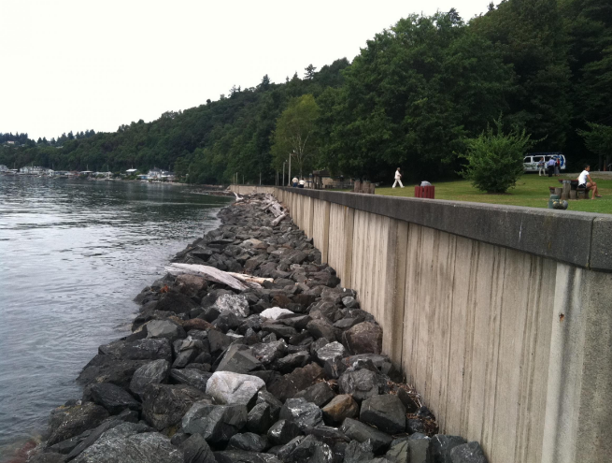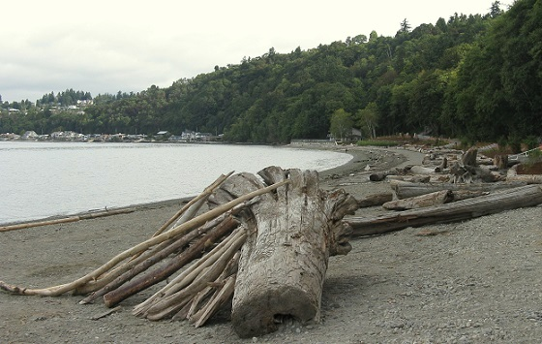

Notes on data

* no planning and project development projects included
* active and completed projects only
* costs reflect PSAR funds only
* best guess at project type using project summary in PRISM

We also discussed linking estuary acres, floodplain acres, and miles of shoreline restored and connect them to our regional targets. However, these metrics are not easily linked in PRISM. The best guess at these metrics are the ones summarized in our 11x17 and don’t fit nicely into these bins. Happy to discuss/brainstorm this further.